

**3T Staging Workflow**

# Table of **Contents**

Table of Contents 1

Document Information and Key 2

Brainstorming 3

Flowchart 4

Process Model 5

Purpose 7

Data Definitions 8

Stage 1: FTP 9

Stage 2: 3T_Import_Staging_Error 9

Stage 3: 3T_Import_Staging 9

Stage 4: Update Import Table 10

Stage 5: Insert for _factPatient 10

Batch Report and Errors 11

# Document Information and Key

Yellow Highlight: Review with team for questions

Green Highlight: Accepted information

# Brainstorming

- What do I need:

- Data Dictionary to describe each of the components of the 3T process, anyone who needs to review what the verbiage describes can use the list to refer to table names, column names, stored procedures, and any other miscellaneous terminology used.

- Do we need to define the reason for the process, or a purpose section?

- ~~Do we need a Requirements Matrix?~~

- ~~Do we need Use Cases?~~

- ~~Do we need Scope?~~

- Do we need Process Model IPOs?

- Is this effectively meant to be more stylized for an SDIP or should this be written more for a User Manual Style?

- Need to document the process for working with members for receiving the 3T Files, explain the pre-step of collecting the data before sending to FTP?

- Need to document the Batch Error communication, how to work with the members on passing or fixing 3T Files for the system

- Need to create simple instructions for navigation, to the batch report, checking the tables, or perhaps the FTP?

-

# Flowchart

# Process Model

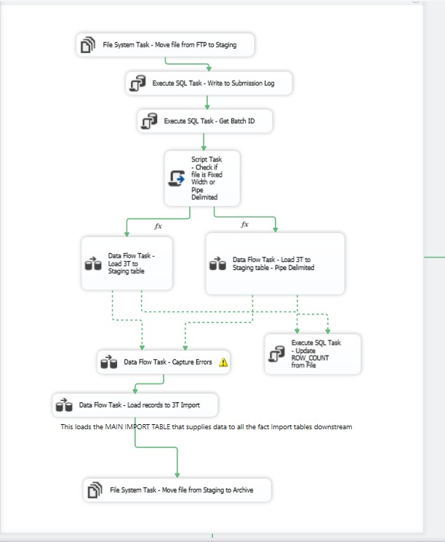

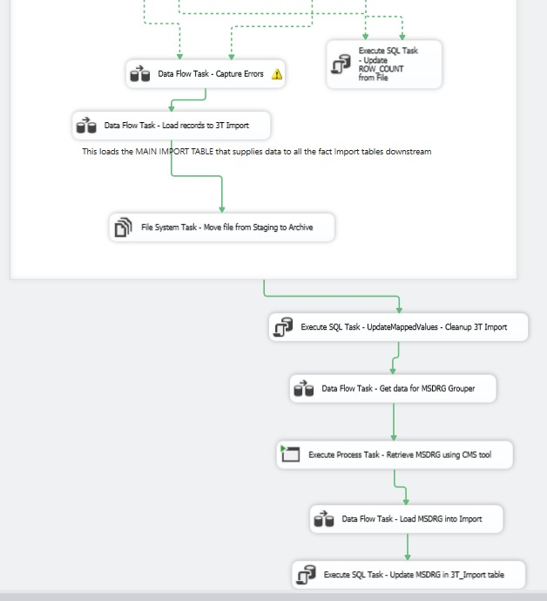

# Purpose

The purpose of this document is to illustrate how the 3T Staging process works within the current infrastructure, and how it can be used to assist members with delivering their data to our internal network. This document explains the high-level technical/functional requirements and provides information about the roles and responsibilities needed to carry out the business processes involved with the file transfer protocol, including the receiving, dissemination, and storage of member data to deliver reporting. It will also describe error tracking and necessary communication with members, if such a situation may arise.

# Data Definitions

- 3T_Files:

- FTP:

- Batch ID:

- 3T_File_Submission Table:

- 3T_Import Table:

- 3T_Import_Staging Table:

- 3T_Import_Staging_Error Table:

- factPatient Table:

- factPatient_Import Table:

- factPhysicianRole Table:

- factProcedure Table:

- factDiagnosis Table:

# Stage 1: FTP

- 3T Files come in as a flat file.

- File comes in different forms: Pipe Delimited, _________

- When a 3T File is sent from a member to the FTP, the file will stay within the FTP during this stage.

- When the file hits the FTP, a couple of processes take place:

- Creates a submission log with an associated Batch ID in the *3T_File_Submission_Log Table*.

- Data from the file is imported into the *3T_Import_Staging Table*.

- Submission log = persistent, - Append to 3T_File_Submission

- *3T_File_Submission_Log Table* is a persistent table, which means it

- Patient Records 🡪 3T_Staging is not persistent/ will not get truncated

# Stage 2: 3T_Import_Staging_Error

- *3T_Import_Staging Table* is used against the *3T_Import_Staging_Error Table.*

- This means the 3T File data is loaded into the *3T_Import_Staging_Error Table* from the *3T_Import_Staging Table.*

- While the data resides in the *3T_Import_Staging_Error Table,* the data gets sent through the *3T_Data_Quality_Rules Table*, where the **RULE_SQL** and the **RULE_IS_ACTIVE** columns are used against the table to find any errors.

# Stage 3: 3T_Import_Staging

- Assuming the file has made it past the error checking, the *3T_Import_Staging* *Table* will be used to load the revised data into the *3T_Import* *Table*.

- Uses the stored procedure called ***usp_Load3TRecordstoImportTable***

- MSDRG grouping

- Currently working in 3T_Import but WILL be replaced to this step

# Stage 4: Update Import Table

- Within the *3T_Import* *Table*, there are values that require updates, namely within the **PAYCODE** (primary payer) and the **STATUS** (discharge status)columns. These values are being updated with hospital defined values from the *refValueMapper* Table, known as the “mapping table”.

- Uses the stored procedure called ***usp_UpdateMappedValues***

# Stage 5: Insert for _factPatient

- 3T_Import inserted into:

- FactDiag, FactProcedure_Import, FactPhy

-IBM process originally

-FactPatient contains the data horizontally, and when inserted into the other fact tables, the date is pivoted.

# Batch Report and Errors